# The Algorithm

This noise gate contains 3 main parts:

* Envelope Follower
* Expander
* Slew Limiter

## Signal Shaper

The signal shaper is a simple 2 pole Highpass + Lowpass filter that is applied to the input signal before it hits the Envelope Follower. These values are fixed at 60Hz for the highpass filter and 2Khz for the lowpass. These filters will remove excessive DC offset from the signal (which may falsely trigger the noise gate to open), as well as noise in the higher range of the audible frequency spectrum. The fundamental frequency range of a standard guitar is 80Hz – 1300hz, so any signal outside that range does little to help accurately detect the guitar sound.

## Envelope Follower

The envelope follower’s job is to estimate the “signal strength” of the input signal, and output a continuous value that “envelopes” the signal. When the player hits a note, it has to react quickly to the change in amplitude, while still producing a smoothly decaying signal while the note decays.

It does this in the following steps:

* Rectify the signal by taking the absolute value of the input sample.
* Apply Band-pass filtering, cutting out low frequencies below 50hz and high frequencies above 2Khz.
* Two “indicators” are computed from the resulting signal:
  + An EMA (exponential moving-average) with a 200Hz cut-off.
  + An SMA (simple moving-average) with a 10ms window.
  + The EMA indicator reacts quickly to changes in amplitude, but is noisy and does not filter out overtones or noise.
  + The SMA produces a very smooth signal with little noise, but it reacts slowly to changes in amplitude.
  + To get the best of both, the two indicators are combined using a simple binary classifier, which tries to determine whether the signal strength is increasing or decreasing. This results in a very fast attack when the player picks a note, and flutter-free smooth decay.
  + The filters are combined with a “peak-hold” function to form the resulting envelope, which is then passed through a smoothing filter.

## Expansion Curve

An expander is the opposite of a compressor. Instead of limiting peaks in volume, it reduces the volume of weak signals. This is controlled by an “expansion curve”, which acts as a mathematical translation. Given a decibel value, it translates it to a new value. The function has 3 parameters, in addition to the input value:

* Threshold – The “cutoff point”, where any value above the threshold remains unaffected, and values below it are reduced by some factor.
* Ratio – The amount of reduction that gets applied. This changes the “slope” of the curve below the threshold.
* Knee – This smooths out the curve around the Threshold point. Instead of having a discontinuity in the curve, the Knee smooths the two parts of the curve so they blend together.

A picture says more than a thousand words. Let’s look at some examples:

|  |  |
| --- | --- |
| C:\Users\Valdemar\AppData\Local\Microsoft\Windows\INetCache\Content.Word\chart2.png  Varying the Threshold | C:\Users\Valdemar\AppData\Local\Microsoft\Windows\INetCache\Content.Word\chart2.png  Varying the Ratio |
|  | |

The expander in Noise Invader is different from many other noise gate effects because it actually uses two expansion curves, with a different threshold and expansion ratio for each. The signal is “clamped” between the two curves, forcing it to follow different paths when increasing or decreasing in amplitude. This brings several benefits:

* The “pick attack” is mostly affected by the shaper lower curve, giving a fast, crisp attack.
* The decay is affected by the more gradually changing upper curve, giving smoothly decaying sustaining notes.
* The area between the two curves acts as a “hysteresis” region, minimizing “chatter”, which would otherwise cause a noise gate to rapidly turn on and off.

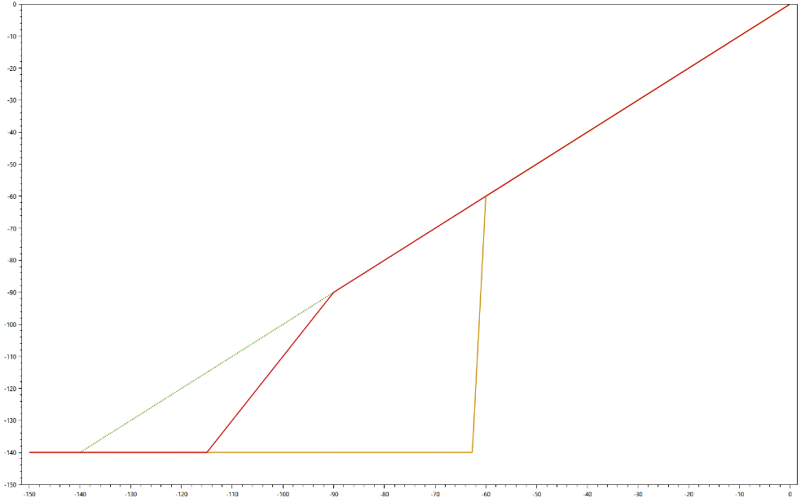

Two curves with different thresholds (-60 and -90). During the attack, the signal will be clamped above the yellow curve and follows that trajectory. During the release, the signal is clamped below the red curve, and follows that trajectory.

The settings in this plugin are fixed at:

* 4dB knee
* 4dB difference in upper and lower threshold
* 2x difference in expansion ratio (the Threshold parameter is applied directly to the upper curve, while 2xThreshold is applied to the lower one).

## Slew Limiter

Finally, a slew limiter is added to the output of the expansion curve translation. A slew limiter simply limits how quickly a signal can increase or decrease. The attack is fixed at 2.0ms/60dB, but the release parameter can be changed by the user (from 10ms/60dB to 1000ms/60dB).

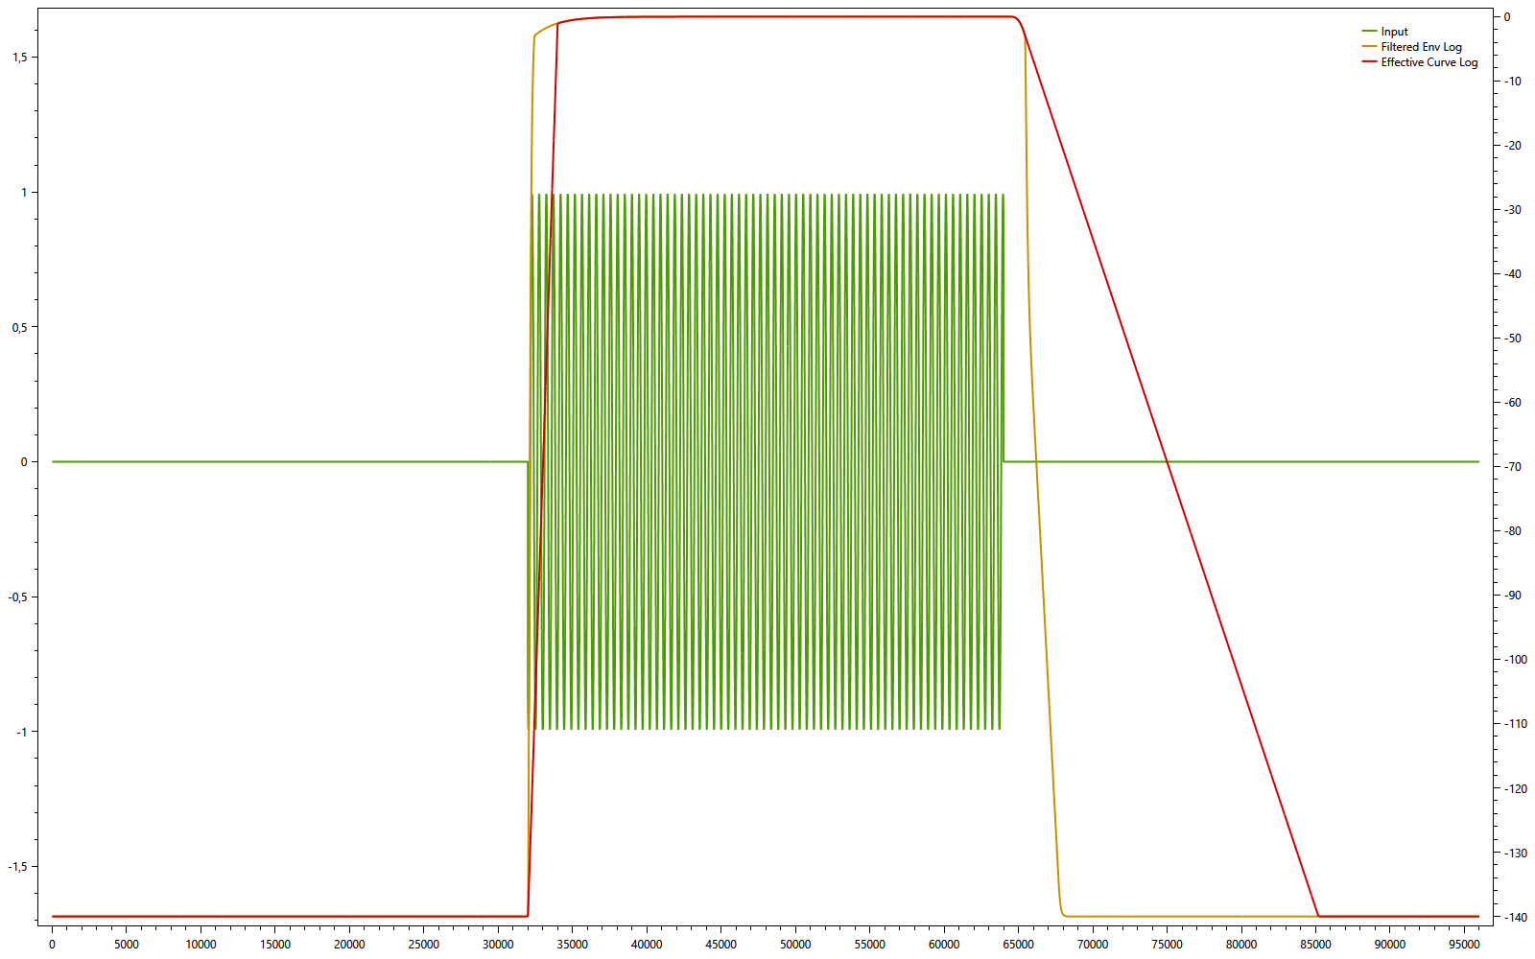

Yellow line: Envelope follower signal.

Red line: Slew limited signal (30ms Attack, 300ms Release).